Week 4: Advanced SOC Activities and Incident Response Workflows

Harsh Vasoya
SOC task – 4
Cyart
25/1/26

Theoretical Knowledge

1. Proactive Threat Hunting Methodologies
Threat hunting is an activity where security analysts actively look for threats inside a network instead of waiting for alerts. Many advanced attacks are designed to avoid detection by security tools, so threat hunting helps identify suspicious behavior that may otherwise go unnoticed. It focuses on finding signs of attackers who are already present in the system.
A common approach to threat hunting is the hypothesis-driven method. In this method, the analyst starts with an assumption, such as “An attacker may be misusing valid user accounts to access sensitive data.” Based on this assumption, logs and system data are reviewed to confirm whether such activity exists. This makes the hunting process more focused and effective.
Threat hunting is often guided by threat intelligence or known attacker behavior. Analysts may look for indicators of compromise from intelligence feeds or search for common attacker techniques, such as the misuse of built-in system tools. By combining different data sources, threat hunting helps improve overall security visibility.

2. Advanced SOAR: Orchestration and Playbooks
Security Orchestration, Automation, and Response (SOAR) helps SOC teams respond to incidents faster and with less manual effort. In many environments, analysts receive a large number of alerts, and handling each one manually can be time-consuming. SOAR tools help automate routine actions and ensure consistent responses.
SOAR works through three main components. Orchestration allows different security tools to work together, such as connecting a SIEM alert with a firewall action. Automation performs repetitive tasks like checking IP reputation or extracting indicators. Playbooks define the steps that should be followed when a specific type of incident occurs.
For example, in a phishing incident, a playbook may automatically extract a suspicious link, check if it is malicious, block it if necessary, and notify the user. This reduces response time and allows analysts to focus on more complex investigations.

3. Post-Incident Analysis and Improvement
Post-incident analysis is performed after an incident has been handled to understand what went wrong and how it can be prevented in the future. Instead of stopping after recovery, SOC teams review incidents to identify weaknesses in security controls or processes.
One commonly used method is the 5 Whys technique, where the analyst keeps asking “why” until the real cause of the incident is found. Another method is the Fishbone Diagram, which helps categorize causes related to people, processes, and technology. These methods help identify the root cause rather than blaming individuals.
SOC metrics such as Mean Time to Detect (MTTD) and Mean Time to Respond (MTTR) are also reviewed during post-incident analysis. These metrics help measure how quickly threats are detected and resolved and indicate areas that need improvement.

4. Adversary Emulation and Defense Testing
Adversary emulation is the practice of simulating real attacker behavior to test security defenses. Instead of only checking for vulnerabilities, this approach tests whether security tools can actually detect and stop known attack techniques.
Using frameworks like MITRE ATT&CK, specific attacker techniques such as phishing or exploitation of services are simulated. Security teams then observe whether alerts are generated and how effectively the SOC responds. This helps identify detection gaps in the environment.
The main outcome of adversary emulation is understanding which attacks are detected and which are missed. This information is used to improve detection rules and response processes, making the SOC more prepared for real-world attacks.

5. Security Metrics and Executive Reporting
Security metrics are used to measure how well the SOC is performing. Metrics such as detection time, response time, and false alert rate help evaluate the effectiveness of security operations. These metrics also help identify areas that need improvement.
Executive reporting focuses on explaining security performance in a simple way for management. Instead of technical logs, reports include summaries, charts, and key findings that show how risks are being reduced. This helps decision-makers understand the value of security efforts.
Clear and simple reporting ensures that security goals are aligned with business objectives and supports better decision-making at the management level.

Task 1: Identification of Suspicious Activity Using Threat Hunting Techniques

Monitoring Environment
The lab environment consisted of two Ubuntu virtual machines configured to simulate a basic SOC setup. One virtual machine acted as the central monitoring system and hosted the Wazuh Manager along with Splunk Enterprise. The second virtual machine functioned as an endpoint system with the Wazuh Agent installed. Secure Shell (SSH) services were enabled on the endpoint system, allowing authentication-related logs to be generated and monitored.
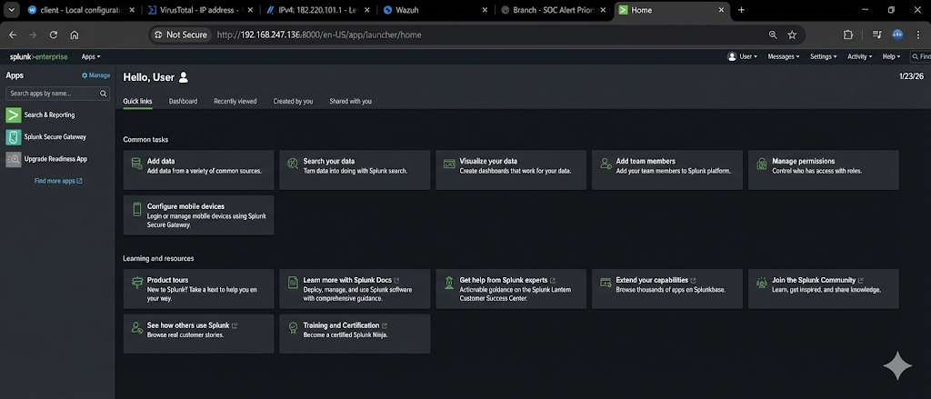

Creation of Authentication Events
To generate security-relevant data, multiple unsuccessful SSH login attempts were performed on the endpoint system. Incorrect credentials were intentionally entered several times to simulate suspicious authentication behavior. These actions resulted in repeated authentication failure entries being written to the Linux authentication log file (/var/log/auth.log). Such patterns are commonly associated with brute-force attempts targeting SSH services.
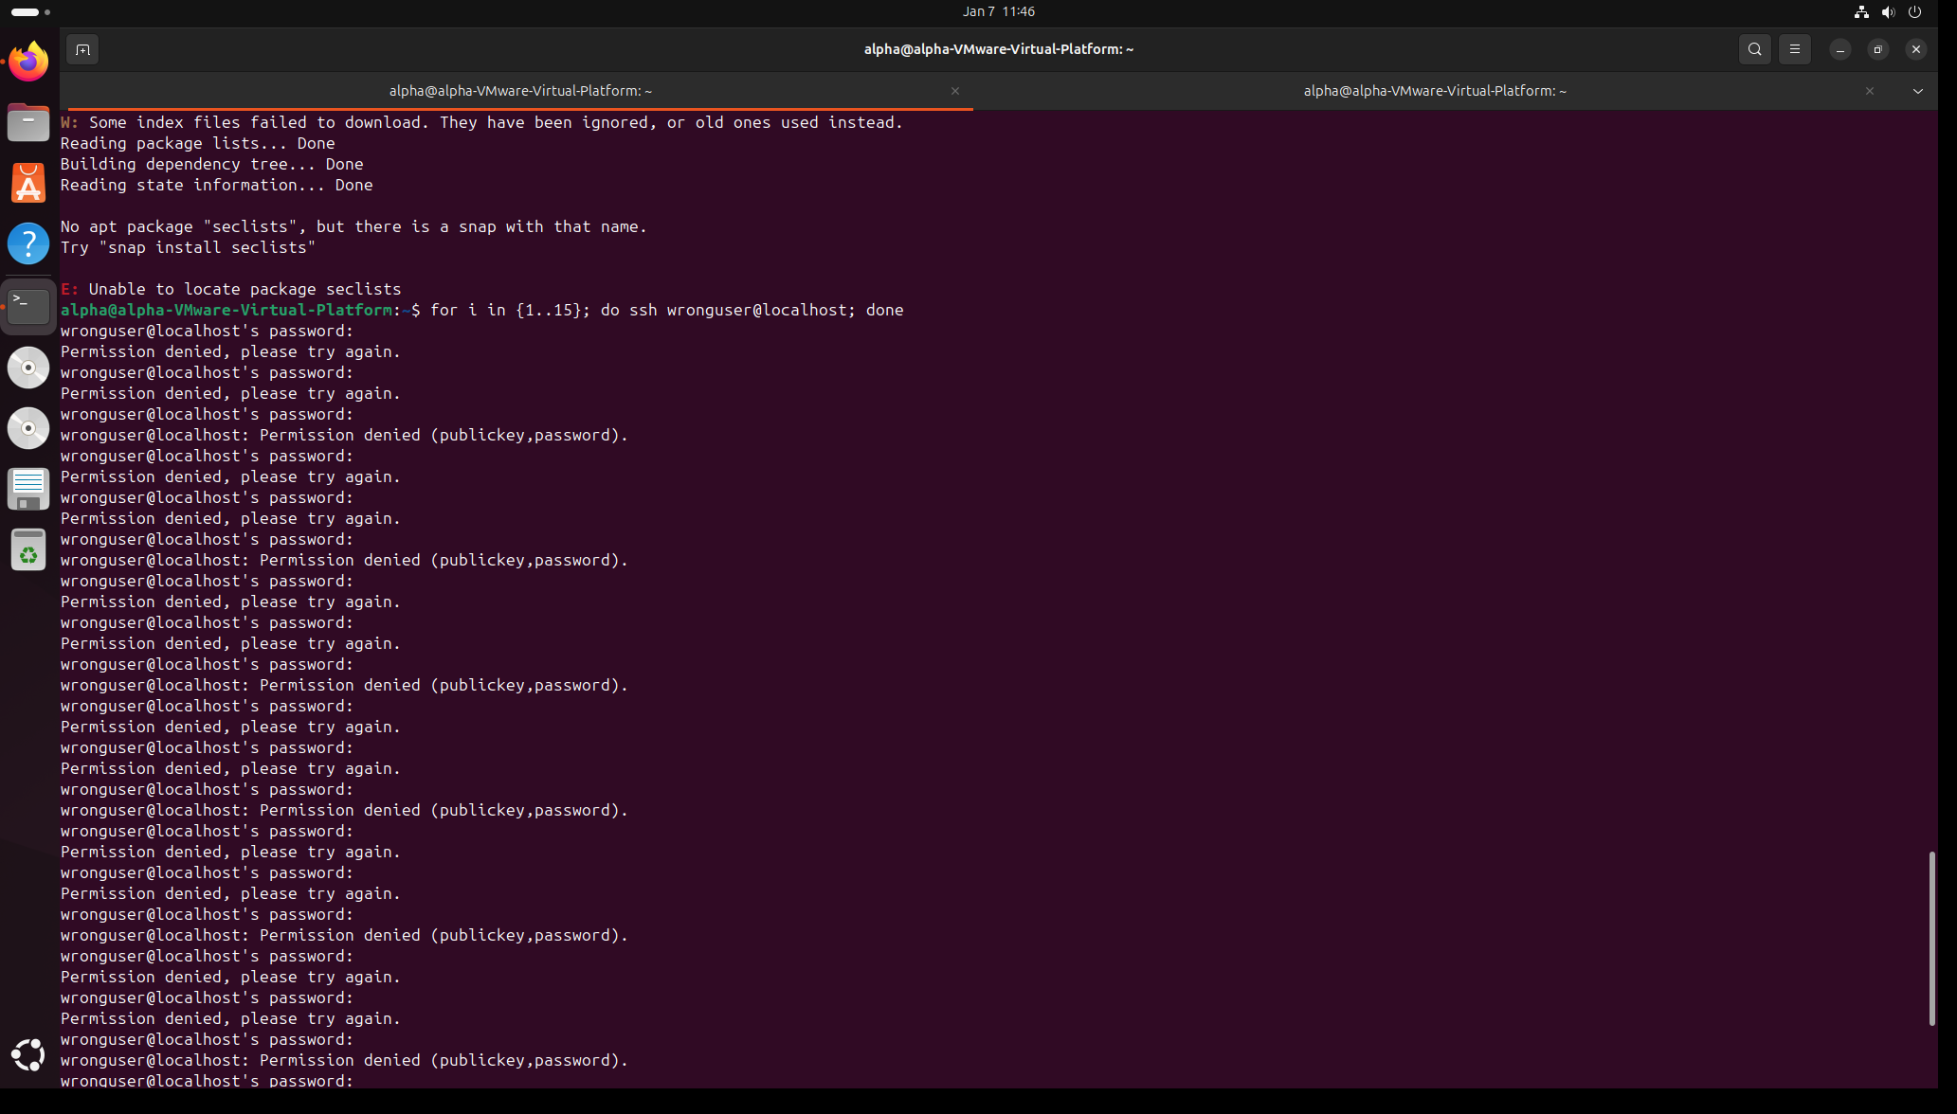

Log Collection and Alert Generation
The Wazuh Agent installed on the endpoint continuously monitored system logs and forwarded them to the Wazuh Manager for analysis. Upon receiving multiple failed authentication events within a short period, Wazuh triggered a security alert. The alert was generated under Rule ID 2502, which detects repeated password authentication failures. This alert was automatically mapped to the MITRE ATT&CK framework under technique T1110 (Brute Force), indicating potential credential access activity.
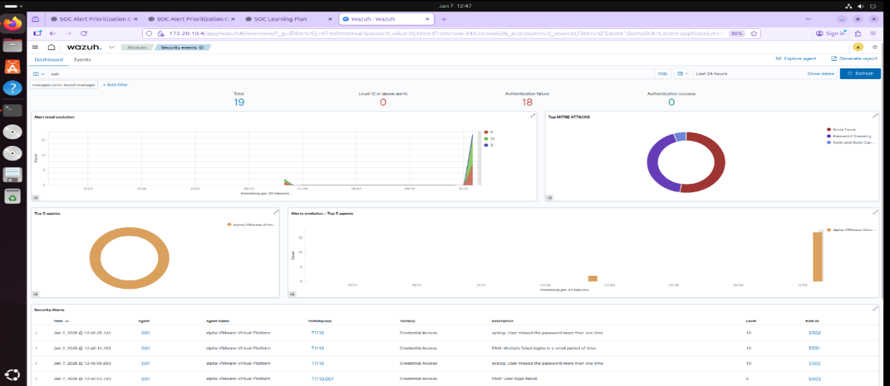

Manual Threat Hunting and Log Analysis
In addition to automated alerting, manual threat hunting was performed using Splunk Enterprise. Authentication logs were ingested into Splunk, where search queries were executed to identify SSH-related failures. By reviewing timestamps, event frequency, and log messages, the analyst was able to validate the behavior detected by Wazuh. This step demonstrated how manual analysis complements automated detection by providing additional context and confirmation.
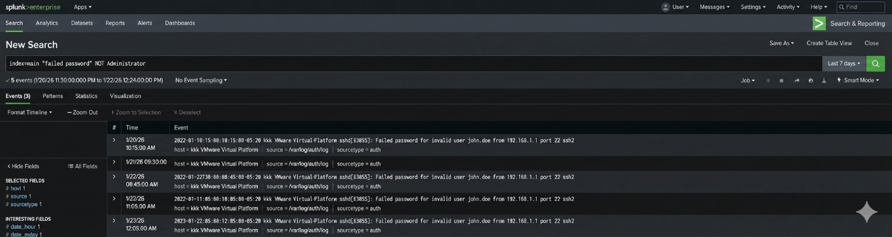

Findings and Interpretation
The investigation confirmed multiple SSH authentication failures occurring within a limited timeframe. No evidence of successful login, privilege escalation, or lateral movement was observed during the analysis. Although the source of the activity was internal, the repeated nature of the failures closely matched known brute-force attack behavior. As a result, the activity was treated as a valid security event for further investigation.

Task 2: Alert Triage, Incident Classification, and IOC Validation

Alert Review and Initial Assessment
After the detection of repeated SSH authentication failures, the alert was reviewed in the Wazuh dashboard. The alert details included the affected system, timestamp, log source, and rule information. The alert was generated under Rule ID 2502, which is designed to detect multiple failed password attempts within a short duration.
During the initial assessment, the frequency and pattern of the failed login attempts were examined to determine whether the alert represented benign activity or a potential security threat.

Alert Triage and Classification
The alert was subjected to triage to determine its validity. The repeated authentication failures matched known brute-force patterns targeting SSH services. Although no successful login was recorded, the behavior was consistent with credential access attempts. Based on this analysis, the alert was classified as a true positive security event.
The incident was assigned a medium severity level, reflecting the presence of suspicious behavior without confirmed system compromise.
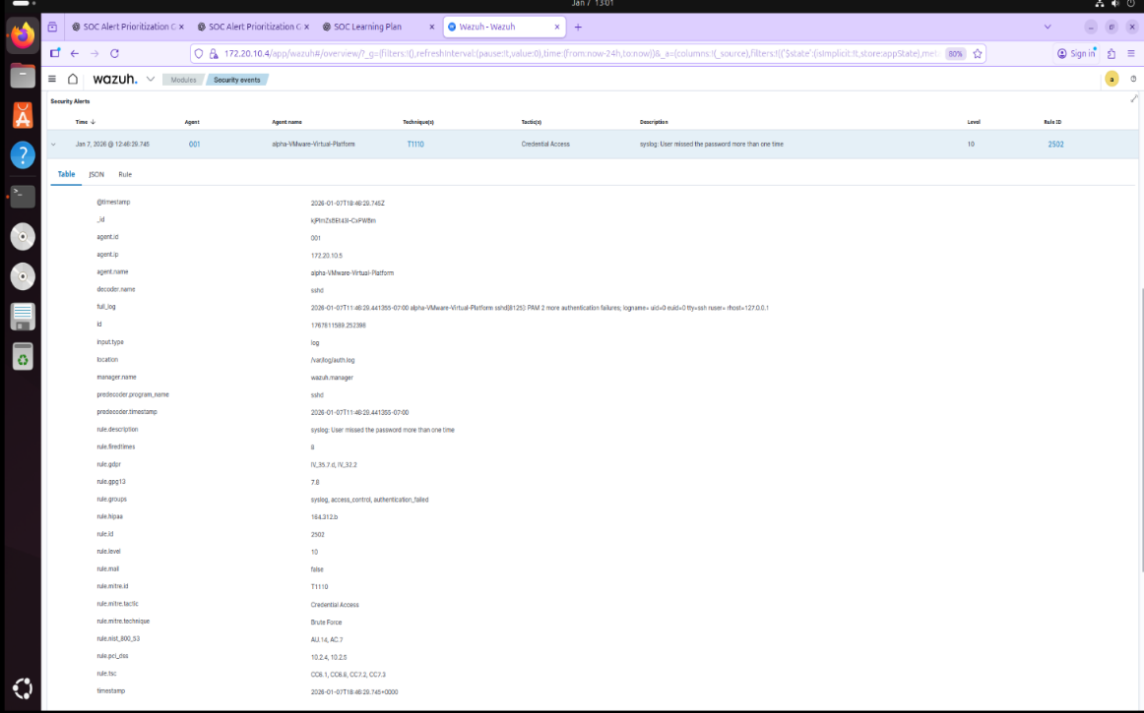

Incident Documentation
Following alert classification, the event was formally documented by creating an incident record. The incident documentation captured key details such as the incident title, affected asset, detection source, severity, and associated MITRE ATT&CK technique. This step ensured that the event was properly tracked and could be referenced during further investigation or escalation. 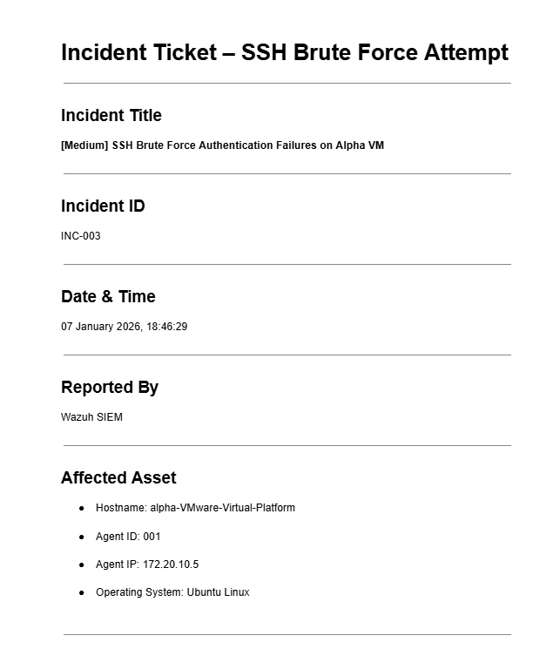

Indicator of Compromise (IOC) Analysis
Relevant indicators were extracted from the alert, including the source IP address and the targeted service. These indicators were validated using external threat intelligence platforms such as VirusTotal and AlienVault OTX. The analysis showed that the source IP address did not have a known malicious reputation and was identified as an internal address.
Despite the absence of malicious intelligence indicators, the behavioral pattern of repeated authentication failures warranted continued monitoring and documentation.
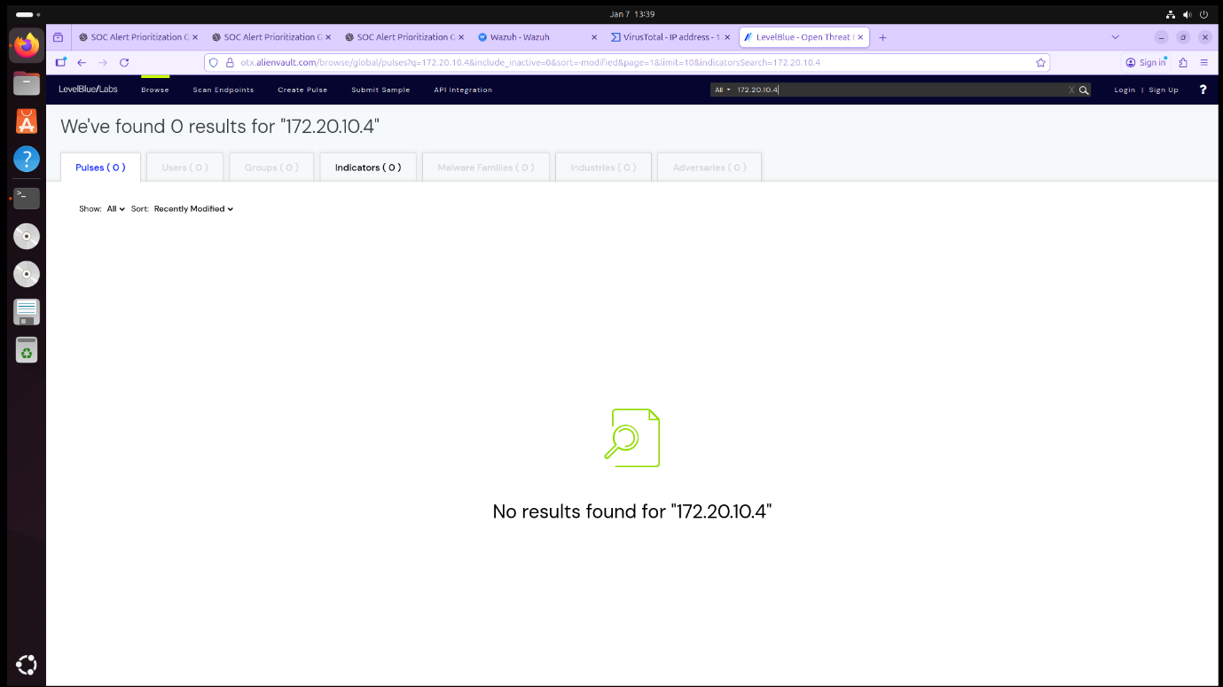

Analyst Decision and Outcome
Based on the triage and IOC validation results, the incident was confirmed as a true positive and marked for monitoring. No immediate containment actions were required, as there was no evidence of successful authentication or further malicious activity. The incident documentation was updated accordingly to reflect the analyst’s assessment and decision.

Task 3: Post-Incident Analysis and Lessons Learned

Objective
The objective of Task 3 was to perform a post-incident analysis of the SSH brute-force incident handled in Task 2. This task focused on identifying the root cause of the incident, evaluating the effectiveness of detection and response, and documenting lessons learned and recommendations for improvement.

Incident Review
The incident reviewed in this task involved multiple failed SSH login attempts detected on a monitored Ubuntu endpoint. The alert was confirmed as a true positive and documented through an incident ticket. No successful authentication, privilege escalation, or data compromise was observed during the investigation.

Root Cause Analysis
A root cause analysis was conducted using the 5 Whys method. The analysis determined that the incident occurred due to repeated incorrect credential attempts against the SSH service. The underlying cause was identified as insufficient SSH hardening, as no account lockout or rate-limiting mechanisms were in place to prevent repeated authentication failures.

Evaluation of Detection and Response
The detection and response mechanisms functioned effectively during the incident. Wazuh successfully detected the suspicious authentication behavior and generated timely alerts. The alert triage and incident documentation processes ensured structured handling and traceability. However, the absence of preventive controls highlighted the need for stronger security configurations.

Lessons Learned
The incident highlighted several important lessons. Detection alone is not sufficient without preventive security controls. SSH services require proper hardening to reduce brute-force risks. Additionally, structured documentation and post-incident analysis are essential for improving SOC maturity and operational effectiveness.

Recommendations for Improvement
Based on the post-incident analysis, the following recommendations were proposed:
- Implement SSH key-based authentication.
- Enable brute-force prevention mechanisms such as account lockout or fail2ban.
- Monitor authentication logs regularly for anomalies.
- Review and update security configurations periodically.

Outcome of Task 3
Task 3 successfully demonstrated the ability to conduct post-incident analysis, identify root causes, and propose actionable improvements. This task reinforced the importance of continuous improvement and lessons learned within SOC operations.

Task 4: Digital Evidence Preservation and Forensic Handling

Evidence Identification
During the investigation, the Linux authentication log file was identified as the primary source of evidence. This log file records SSH login attempts, including failed authentications, timestamps, and user details, making it critical for forensic analysis of the incident.
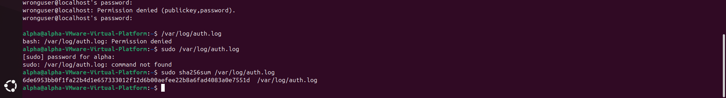

Evidence Collection and Protection
A forensic copy of the authentication log file was created instead of working on the original file. This approach ensured that the original evidence remained unchanged. The copied file was stored in a secure location and assigned read-only permissions to prevent any modification during analysis or review.

Integrity Verification
To verify the integrity of the preserved evidence, a cryptographic hash was generated using the SHA-256 algorithm. The hash value served as a reference point to confirm that the evidence file was not altered after collection.

Chain of Custody Maintenance
A chain of custody record was maintained to document the handling of the evidence. This record included details such as the time of collection, the individual responsible, and the actions performed on the evidence. Maintaining this record ensured accountability and traceability throughout the incident response process.

Chain of Custody – SSH Brute Force Incident

Incident Reference
- Incident ID: INC-003
- Incident Type: SSH Brute Force Authentication Failures
- Detection Tool: Wazuh SIEM

Evidence Identification
- Evidence Type: System Authentication Log
- Description: SSH authentication failure records related to repeated login attempts
- Original File Location: /var/log/auth.log
- Associated Service: SSH (sshd)

Evidence Collection Details
- Collected From Host: alpha-VMware-Virtual-Platform
- Agent ID: 001
- Agent IP: 192.168.247.135
- Date & Time of Collection: 22 January 2026, 01:18 IST
- Collected By: SOC Analyst
- Collection Method: Secure file copy using administrative privileges

Evidence Preservation
- Copied Evidence Location: /home/alpha/auth.log.evidence
- File Permissions Applied: Read-only (chmod 444)
- Access Restriction: Modification disabled to preserve integrity

Integrity Verification
- Hash Algorithm Used: SHA-256
- Generated Hash Value:
02807ea84d0c28d86d0dc5c7fa282d91bc079a8be40b3a68b220a8dee88589e1
- Integrity Status: Verified – No alteration detected

Chain of Custody Log
Date & Time (IST) | Action Performed | Performed By
22-01-2026 01:18 | Evidence identified and copied | SOC Analyst
22-01-2026 01:20 | File permissions set to read-only | SOC Analyst
22-01-2026 01:22 | SHA-256 hash generated | SOC Analyst
22-01-2026 01:25 | Evidence stored securely | SOC Analyst

Current Evidence Status
- Storage Location: Secured local directory
- Condition: Preserved and unmodified
- Availability: Available for audit or further investigation
.

Task 5 – Incident Escalation and Communication

Situation Report (SITREP)

Incident Title
SSH Brute Force Authentication Failures on Alpha VM

Incident ID
INC-003

Date & Time Detected
22 January 2026, 18:46 IST

Reported By
Wazuh SIEM

Affected Asset
- Hostname: alpha-VMware-Virtual-Platform
- Agent ID: 001
- Agent IP: 192.168.247.135
- Operating System: Ubuntu Linux

Incident Summary
Wazuh SIEM detected multiple failed SSH authentication attempts on the Alpha VM within a short time period. The alert was generated by Rule ID 2502 and classified under MITRE ATT&CK technique T1110 (Brute Force). The activity indicates repeated login attempts that could potentially lead to unauthorized access if left unchecked.

Impact Assessment
- No successful login was detected.
- No data compromise observed.
- Risk level assessed as Medium due to repeated authentication failures.

Actions Taken
- Alert triage performed and confirmed as True Positive.
- Authentication logs collected and preserved as evidence.
- File integrity verified using SHA-256 hashing.
- Incident escalated to Tier 2 for deeper analysis.

Current Status
- Incident is under investigation.
- No containment action required at this stage.
- Monitoring continues for additional suspicious activity.

Recommended Next Steps
- Review SSH configuration and authentication policies.
- Implement account lockout or rate-limiting for SSH.
- Continue monitoring for further failed login attempts.
- Consider disabling unused user accounts.

Escalation Level
Escalated from Tier 1 (Triage) to Tier 2 (Investigation)

Prepared By
SOC Analyst

